Ref: <https://console.ng.bluemix.net/docs/containers/container_single_ui.html#container_gettingstarted_tutorial>

Install the Cloud Foundry CLI tool from <https://github.com/cloudfoundry/cli#downloads>

~~Install the IBM Bluemix Container Service plug-in to execute commands to IBM Bluemix containers from your terminal window.~~

Install the Bluemix CLI - <http://clis.ng.bluemix.net/ui/home.html> (and Restart :-( )

…

Followed up to Step 12 but now getting an issue after running bx ic init:

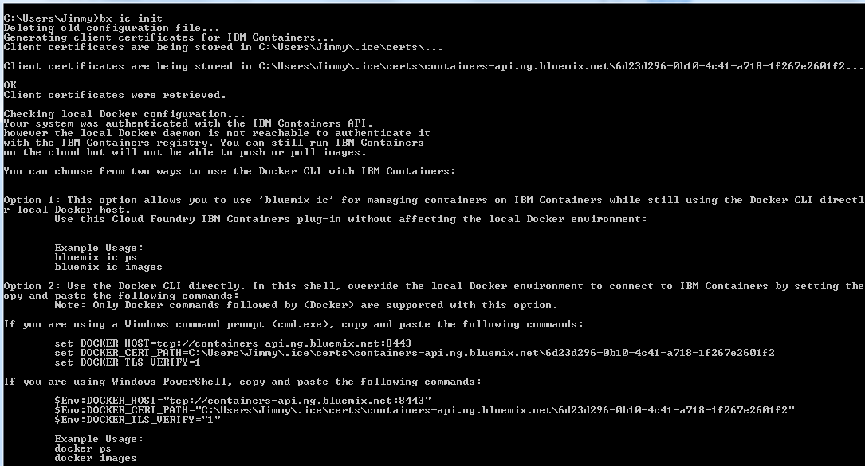

Tried Option 2 as listed and it seemed to work:

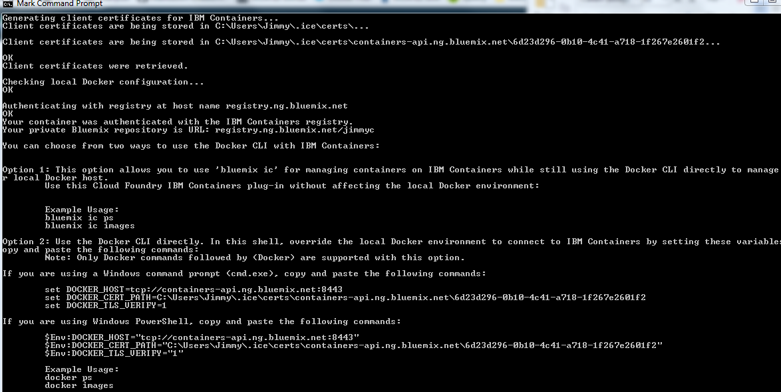

Private repo URL is: registry.ng.bluemix.net/jimmyc

On to Step 13..done.

**Pushing Images to Bluemix**

Upload via Docker as a normal using the private repo URL above:

Tag:

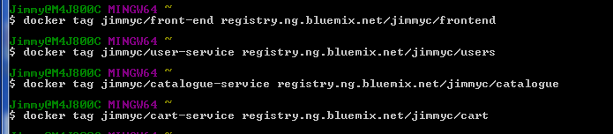

Then upload each one (specify the tag)

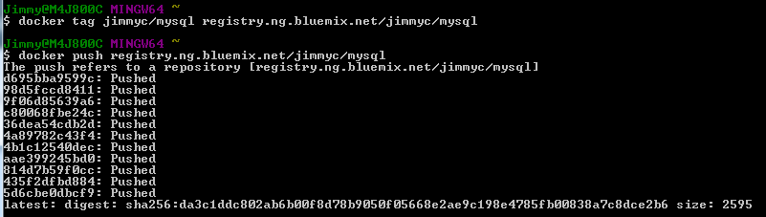

How to get containers to talk to each other?

<https://console.ng.bluemix.net/docs/containers/container_integrations.html#container_integrations_binding> ->> ??